**Chapter 1**

**INTRODUCTION**

**C**ricket is a sport that generates a large number of statistics.Statistics are recorded for each player during a match, and aggregated over a career. At the professional level, statistics for Test cricket, one-day internationals, and first-class cricket are recorded separately. However, since Test matches are a form of first-class cricket, a player's first-class statistics will include their Test match statistics – but not vice versa.

Nowadays records are also maintained for List A and Twenty20 limited over matches. These matches are normally limited over games played domestically at the national level by leading Test nations. Since one-day internationals are a form of List A limited over matches, a player's List A statistics will include their ODI match statistics – but not vice versa.

* Innings (I): The number of innings in which the batsman actually batted.
* Not outs (NO): The number of times the batsman was not out at the conclusion of an innings they batted in.
* Runs (R): The number of runs scored.
* 4's: The number of 4's the batsmen has scored.
* 6's: The number of 6's the batsmen has scored.
* Highest score (HS/Best): The highest score ever made by the batsman.
* Batting average (Ave): The total number of runs divided by the total number of innings in which the batsman was out.
* Ave = Runs/[I – NO] (also Avge or Avg.)
* Centuries (100): The number of innings in which the batsman scored one hundred runs or more.
* Half-centuries (50): The number of innings in which the batsman scored fifty to ninety-nine runs (centuries do not count as half-centuries as well).
* Balls faced (BF): The total number of balls received, including no balls but not including wides.
* Strike rate (SR): The average number of runs scored per 100 balls faced. (SR = [100 * Runs]/BF)

**Chapter 2**

**SYSTEM REQUIREMENTS**

**2.1 Hardware requirements -**

* Disk space of 500Mb
* RAM (1Gb or more)

**2.2Software requirements -**

* Eclipse Mars 2
* JDK
* Windows 7/8/8.1/10
* MYSQL
* MS WORD

**Chapter 3**

**PROBLEM DESCRIPTION**

**CRICKET PLAYER STATISTICS DATABASE**

Player Statistics depends on the number of matches the player has played, number of runs the player has scored. Matches and Tournaments will be conducted by some International Cricket boards. In this Database, the user can add or delete Players. The user can also update the Statistics of Players.

Rank and Statistics of all Players are described in the given tables.

* PLAYER
* TOURNAMENT
* FIXTURES
* RANK
* STATISTICS

The table details are as follows:

Table 3.1 PLAYER

|  |  |  |  |
| --- | --- | --- | --- |
| **COLUMN NAME** | **DATATYPE & SIZE** | **CONSTRAINTS** | **DESCRIPTION** |
| P_ID | INT | PRIMARY KEY | Accepts integer type data |
| P_NAME | VARCHAR(20) |  | Accepts player name |
| GENDER | VARCHAR(20) |  | Player gender |
| AGE | INT |  | Accepts integer type. i.e Player age |
| HEIGHT | VARCHAR(20) |  | Accepts height of player |
| ROLE | VARCHAR(20) |  | 'BATSMAN' or 'BOWLER' |
| COUNTRY | VARCHAR(20) |  | Accepts coountry name |

Table 3.2 TOURNAMENT

|  |  |  |  |
| --- | --- | --- | --- |
| **COLUMN NAME** | **DATATYPE & SIZE** | **CONSTRAINTS** | **DESCRIPTION** |
| T_ID | VARCHAR(20) | PRIMARY KEY | ID of the tournament |
| T_NAME | VARCHAR(20) |  | name of the tournament |
| TYPE | VARCHAR(20) |  | 'ODI' or 'T20' or 'TEST' |
| YEAR | INT |  | Year of tournament |
| LOCATION | VARCHAR(20) |  | Tournament played in |

Table 3.3 FIXTURES

|  |  |  |  |
| --- | --- | --- | --- |
| **COLUMN NAME** | **DATATYPE & SIZE** | **CONSTRAINTS** | **DESCRIPTION** |
| F_ID | VARCHAR(20) |  | Fixture ID |
| P_ID | INT | REFERENCES P_ID FROM PLAYER | Player ID |
| P_NAME | VARCHAR(20) | REFERENCES P_NAME FROM PLAYER | Player name |
| T_ID | VARCHAR(10) | REFERENCES T_ID FROM TOURNAMENT | Tournament ID |
| RUNS | INT |  | No of runsby the player |
| WICKETS | INT |  | No of wickets by the player |

Table 3.4 RANK

|  |  |  |  |
| --- | --- | --- | --- |
| **COLUMN NAME** | **DATATYPE & SIZE** | **CONSTRAINTS** | **DESCRIPTION** |
| P_ID | INT | PRIMARY KEY | Player ID |
| P_NAME | VARCHAR (50) |  | Player Name |
| ODI | INT |  | Rank in ODI |
| T 20 | INT |  | Rank in T 20 |
| TEST | INT |  | Rank in TEST |

Table 3.5 STATISTICS

|  |  |  |  |
| --- | --- | --- | --- |
| **COLUMN NAME** | **DATATYPE & SIZE** | **CONSTRAINTS** | **DESCRIPTION** |
| P_ID | INT | PRIMARY KEY | Player ID |
| P_NAME | VARCHAR(20) | REFERENCES  P _NAME FROM PLAYER | Player Name |
| MATCHES | INT |  | Total Matches |
| RUNS | INT |  | Total Runs |
| WICKETS | INT |  | Total Wickets |
| HUNDREDS | INT |  | No. of Centuries |
| FIFTIES | INT |  | No. of Half Centuries |
| HIGH SCORE | INT |  | Highest score scored |
| STRIKE RATE | VARCHAR(20) |  | Strike rate of the Player |
| AVERAGE | VARCHAR(20) |  | Average of the Player |

**Chapter 4**

**SYSTEM DESIGN**

**3.1 ER DIAGRAM** : It is a Entity-Relationship model composed of entity types and specifies relationships that can exist between instances of those entity types.

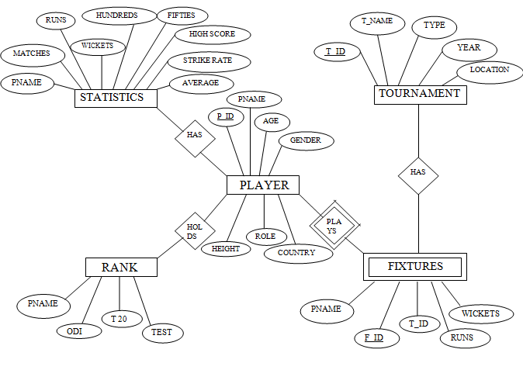

Fig 3.1: ER diagram for Cricket Player Statistics Database

**3.2 SCHEMA DIAGRAM :** A representation of logical configurations of all or part of a relational database.

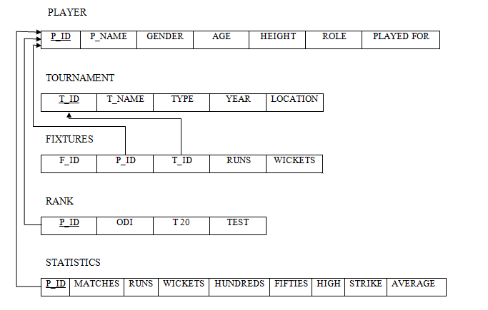

Fig 3. 1:Schema diagram for Cricket Player Statistics Database

Cricket Player Statistics Database

**NORMALIZATION FORMS**

**FIRST NORMAL FORM (1NF) :** As per First Normal Form, no two Rows of data must contain repeating group of information i.e. each set of columns must have a unique value, such that multiple columns cannot be used to fetch the same row. Each table should be organized into rows, and each row should have a primary key that distinguishes it as unique.

**SECOND NORMAL FORM (2NF) :** As per the Second Normal Form there must not be any partial dependency of any column on primary key. It means that for a table that has concatenated primary key, each column in the table that is not part of the primary key must depend upon the entire concatenated key for its existence. If any column depends only on one part of the concatenated key, then the table fails Second normal form.

**THIRD NORMAL FORM (3NF) :** Third Normal form applies that every non-prime attribute of table must be dependent on primary key, or we can say that, there should not be the case that a non-prime attribute is determined by another non-prime attribute. So this *transitive functional dependency* should be removed from the table and also the table must be in Second Normal form

Above tables follows all three Normalization Forms.

**Chapter 5**

**IMPLEMENTATION**

Following code is used to establish connection with the back-end Database :

import java.sql.*;

import javax.swing.JOptionPane;

public class jconnect

{

Connection conn=null;

public static Connection connectdb()

{

try{

Class.forName("com.mysql.jdbc.Driver");

Connectionconn=DriverManager.getConnection("jdbc:mysql://127.0.0.1/demo","root","QWERTY");

JOptionPane.showMessageDialog(null,"connected to database");

return conn; }

catch(Exception e)

{

JOptionPane.showMessageDialog(null, e);

return null;

}

}

public static void main(String args[]) throws IOException{

}}

**Chapter 6**

**SCREENSHOTS**

Fig 6.1 LOGIN

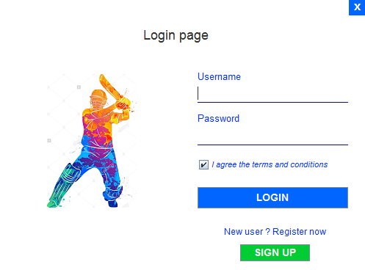

Fig 6.2 HOME

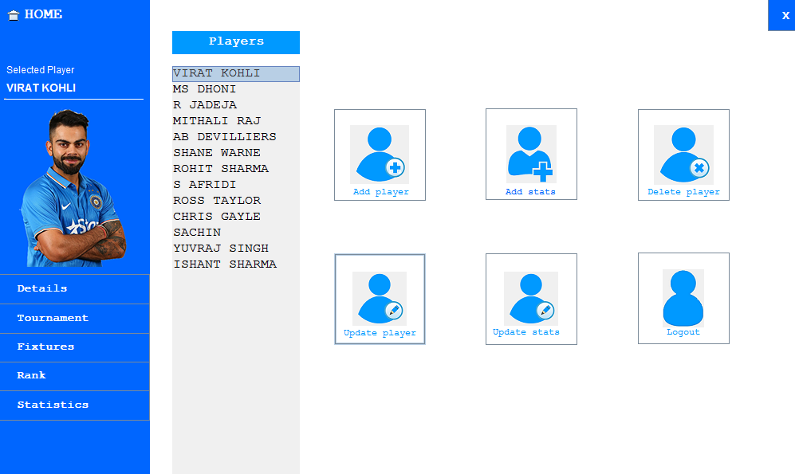

Fig 6.3 ADD NEW PLAYER

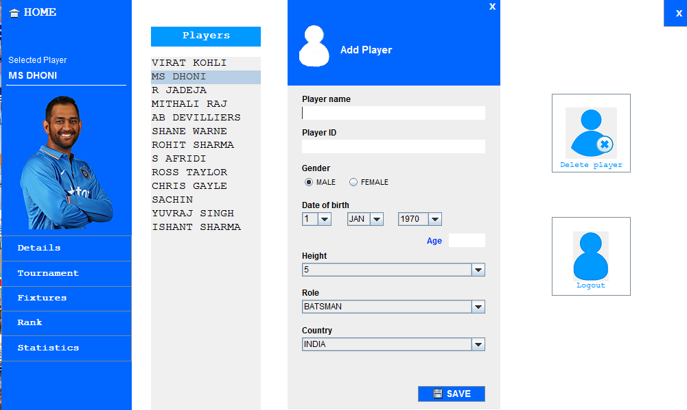

**CONCLUSION**

A player's ability to get off strike in one-day cricket is crucial to a flowing team innings, yet scoring-shot percentage is never spoken about. The importance of bowling balls that ask a question of the batsman's length footwork is drilled in at team meetings, but never given a full statistical evaluation

Besides observing the Laws, cricketers must respect the "Spirit of the Game" and the Preamble to the Laws, first published in the 2000 code, opens with this statement: "Cricket is a game that owes much of its unique appeal to the fact that it should be played not only within its Laws but also within the Spirit of the Game".

The onus for ensuring that a team complies is placed firmly on the captain who may be required by the umpires to "take action" against any player on his team whose behaviour is unacceptable and may bring the sport into disrepute. The umpires are the sole judges of fair and unfair play. They are required to intervene if players are inter alia wasting time, damaging the pitch, tampering with the ball or showing disrespect to other players or to the umpires themselves.

Nowadays records are also maintained for List A and Twenty20 limited over matches. These matches are normally limited over games played domestically at the national level by leading Test nations. Since one-day internationals are a form of List A limited over matches, a player's List A statistics will include their ODI match statistics – but not vice versa.

BIBLIOGRAPHY

[1] Database systems Models, Languages, Design and Application Programming,

RamezElmasri and Shamkant B. Navathe, 7th Edition, 2017, Pearson.

[2] Database management systems, Ramakrishnan, and Gehrke, 3rd Edition,2014,

McGraw Hill.

[1] <https://netbeans.org/downloads/>

[2] <https://www.apachefriends.org/index.html>

[3] <https://www.tutorialspoint.com/netbeans_online_training/>